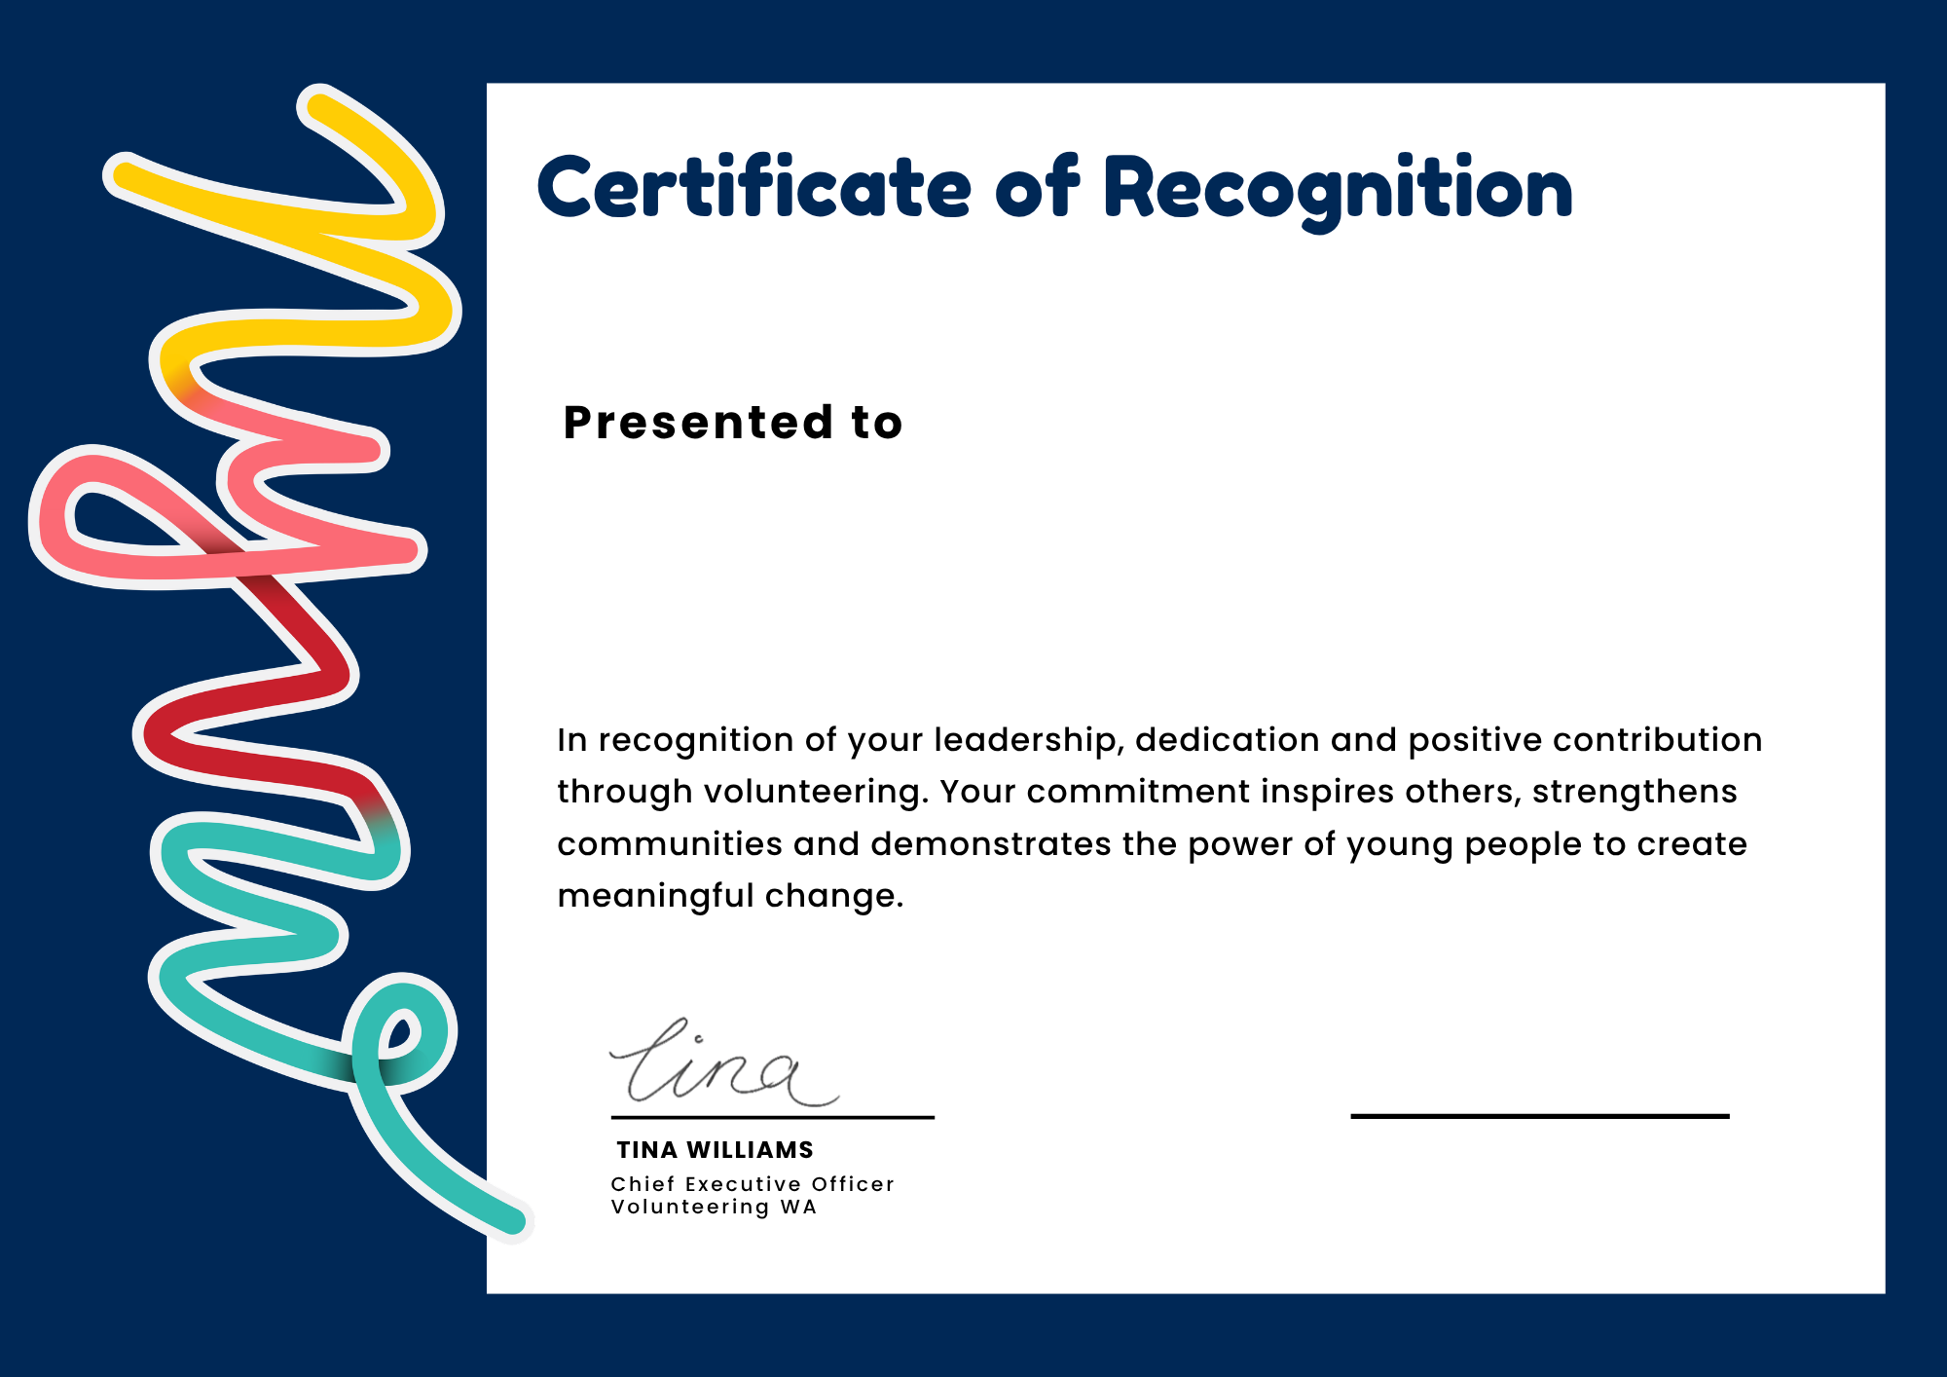
Insert name
Role
Organisation
Name

